**Introduction:**

This report details the results of a double round-robin tournament designed to evaluate the performance of an improved Reconnaissance Chess playing agent (hereafter referred to as "ImprovedAgent"). The ImprovedAgent was tested against three other agents, with each matchup consisting of two games where each agent played as both White and Black over various rounds.

**Overview of Agents:**

The tournament included the following agents:

* **ImprovedAgent:** The primary focus of this evaluation, ImprovedAgent incorporates strategic sensing methods.
* **RandomBot:** A baseline agent provided by the ReconChess library, which selects moves and senses randomly.
* **RandomSensingAgent:** A variant of ImprovedAgent, this agent uses random sensing instead of ImprovedAgent's strategic sensing
* **TroutBot**

**Improvements in the Sensing Method (ImprovedAgent):**

The ImprovedAgent incorporates the following sensing strategies:

* TroutBot’s improvements (more detail to be written)
* Lath’s improvements
* Lath’s improvements
* **Entropy-Based Sensing (Information Gain):** Inspired by Perrotta et al. (2022), this method aims to reduce uncertainty across the agent's hypothesized board states. The agent simulates the outcomes of each possible sense action across a sample of 100 board states and selects the square that yields the most varied results, thus providing the highest information gain.
* **Potential Opponent Moves and Piece Values:** This strategy prioritizes gathering information about potentially dangerous or valuable opponent pieces and their possible locations. This proactive approach is designed to improve threat prevention and attack planning compared to simply reacting to immediate events.

**Important Considerations in Sensing Strategy:**

Several factors influence the effectiveness of sensing strategies:

* **Context Matters:** The optimal sensing strategy can vary depending on the game phase and specific situation. For instance, information gain might be more critical in the opening, while threat assessment becomes more important later in the game.
* **Exploration vs. Exploitation:** Balancing information gathering with exploiting known weaknesses is crucial. A purely information-gathering approach might miss tactical opportunities

**Tournament Results**

(updated graph to be used)

**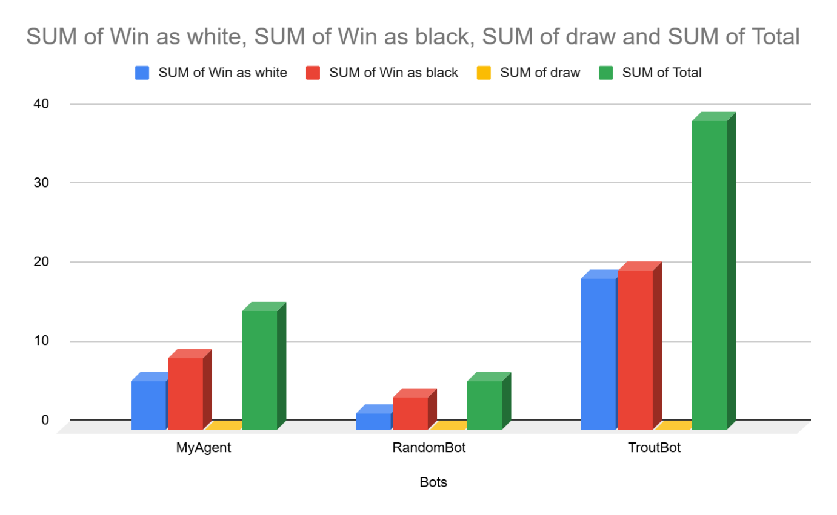   
Analysis**

**ImprovedAgent vs Baseline Agents**: The ImprovedAgent demonstrated a clear advantage over the baseline agents, RadomBot and RandomSensingAgent, winning all it’s games against each. This also confirms the effectiveness of the implemented sensing strategy in outperforming random sensing.

**ImprovedAgent vs TroutBot:** The improvedAgent has demonstrated a significant leap in performance, now consistently outperforming the TroutBot. Previously, TroutBot held the upper hand. The occasional losses by the ImprovedAgent are typically attributed to Stockfish timeouts, this can be attributed to the growing number of boards states during computation, this indicates a computational constraint rather than a strategic deficiency.

TroutBot’s Peromance: TroutBot exhibited stronger performance when matched up against the baseline agent, against the RandomSensingBot is expectedly beats the it since it has strategic approach to sensing. The TroutBot underperforms compared to the ImprovedaAgent, and fails to win with any consistency.

**RandomBot and RandomSensingAgent:** RandomSensingAgent and RandomBot performed similarly (more details to be added).

**Conclusion**

The improvedagents’s improved sensing logic demonstrates a significant improvement over the random sensing approach, the agent consistently and outperforms not only RandomBot and RandomSensingAgent, but also the more advanced TroutBot. This performance gain comes at the cost of generating many possible board states, which can reduce the time available for Stockfish to compute moves, adequate error handling has been implemented to prevent crashes from shutting down the agent. With further optimization in processing efficiency, the improvedAgent’s dominance over TroutBot would be even more solidified.

| **Rounds** | **Bots** | **Win as white** | **Win as black** | **draw** | **Total** |
| --- | --- | --- | --- | --- | --- |
| **Round 1** |  |  |  |  |  |
|  | **MyAgent** | 1 | 1 |  | 2 |
|  | **TroutBot** | 2 | 2 |  | 4 |
|  | **RandomBot** | 0 | 0 |  | 0 |
| **Round 2** |  |  |  |  |  |
|  | **MyAgent** | 0 | 1 |  | 1 |
|  | **TroutBot** | 2 | 2 |  | 4 |
|  | **RandomBot** | 0 | 1 |  | 1 |
| **Round3** |  |  |  |  |  |
|  | **MyAgent** | 1 | 1 |  | 2 |
|  | **TroutBot** | 2 | 2 |  | 4 |
|  | **RandomBot** | 0 | 0 |  | 0 |
| **Round 4** |  |  |  |  |  |
|  | **MyAgent** | 1 | 2 |  | 3 |
|  | **TroutBot** | 1 | 2 |  | 3 |
|  | **RandomBot** | 0 | 0 |  | 0 |
| **Round 5** |  |  |  |  |  |
|  | **MyAgent** | 0 | 0 |  | 0 |
|  | **TroutBot** | 2 | 2 |  | 4 |
|  | **RandomBot** | 1 | 1 |  | 2 |
| **Round 6** |  |  |  |  |  |
|  | **MyAgent** | 1 | 1 |  | 2 |
|  | **TroutBot** | 2 | 2 |  | 4 |
|  | **RandomBot** | 0 | 0 |  | 0 |
| **Round 7** |  |  |  |  |  |
|  | **MyAgent** | 1 | 0 |  | 1 |
|  | **TroutBot** | 2 | 2 |  | 4 |
|  | **RandomBot** | 1 | 0 |  | 1 |
| **Round 8** |  |  |  |  |  |
|  | **MyAgent** | 0 | 1 |  | 1 |
|  | **TroutBot** | 2 | 2 |  | 4 |
|  | **RandomBot** | 0 | 1 |  | 1 |
| **Round 9** |  |  |  |  |  |
|  | **MyAgent** | 1 | 1 |  | 2 |
|  | **TroutBot** | 2 | 2 |  | 4 |
|  | **RandomBot** | 0 | 0 |  | 0 |
| **Round 10** |  |  |  |  |  |
|  | **MyAgent** | 0 | 1 |  | 1 |
|  | **TroutBot** | 2 | 2 |  | 4 |
|  | **RandomBot** | 0 | 1 |  | 1 |

|  |  |  |  |  |
| --- | --- | --- | --- | --- |
| *Bots* | SUM of Win as white | SUM of Win as black | SUM of draw | SUM of Total |
|  | 0 | 0 | 0 | 0 |
| MyAgent | 6 | 9 | 0 | 15 |
| RandomBot | 2 | 4 | 0 | 6 |
| TroutBot | 19 | 20 | 0 | 39 |
| **Grand Total** | **27** | **33** | **0** | **60** |